
COMSATS University Islamabad (CUI)

Software Design Description
(SDS DOCUMENT)

for
Complytics
Version 1.0
By
Ayesha Hissam CIIT/SP22-BDS-012/ISB
Khizar Ahmed CIIT/SP22-BDS-021/ISB

Supervisor
Madam Nusrat Shaheen

Co-Supervisor
Waleed Umar

Bachelor of Science in Computer Science (2022-2026)

Table of Contents
Revision History iii
Application Evaluation History iv
1. Introduction 1
2. Design Methodology and Software Process Model 1
3. System Overview 1
3.1 Architectural Design 1
4. Design Models 1
5. Data Design 2
5.1 Data Dictionary 2
6. Human Interface Design 2
6.1 Screen Images 2
6.2 Screen Objects and Actions 2
7. Implementation 3
7.1 Algorithm 3
7.2 External APIs/SDKs 5
7.3 User Interface 5
7.4 Deployment 8
8. Testing and Evaluation 9
8.1 Unit Testing 9
8.2 Functional Testing 9
8.3 Business Rules Testing 10
8.4 Integration Testing 10
Appendix A 11
Appendix B 13

Revision History
Name | Date | Reason for changes | Version

Application Evaluation History

Comments (by committee)  *include the ones given at scope time both in doc and presentation | Action Taken

Supervised by
Supervisor’s Name
Signature______________

1. Introduction
The Software Requirements Specification (SRS) outlines the details and specifications for the Complytics project. This section provides an overview of the entire SRS, including its purpose, scope, modules, and structure.

Purpose
The purpose of creating this Software Requirements Specification (SRS) document is to provide a comprehensive foundation for the development of Complytics, an AI-driven security compliance automation platform. By detailing the specific requirements and objectives in this SRS, we aim to ensure that developers, project managers, and stakeholders have a clear understanding of how this platform will streamline security compliance processes across organizations. This document serves as a blueprint for translating complex compliance requirements into an automated solution that integrates AI-powered document analysis, cloud security scanning, and intelligent compliance guidance. In simpler terms, this SRS acts as a detailed roadmap that will guide the development team in creating a system that effectively transforms manual compliance processes into an efficient, automated platform.

Scope
The Complytics platform is an AI driven tool made to assist businesses in automating and managing their security compliance procedures. The platforms eight core modules working together to provide a comprehensive compliance solution. The system starts with basic user management allowing different roles like Compliance Teams and administrators to access the platform. At its heart the platform uses AI to analyze compliance documents and automatically configure azure active directory setting based on compliance requirements.
The AI driven UI testing module automatically checks websites for security and accessibility compliance the platform includes a knowledge base that stores and organizes compliance framework like ISO 27001 in an easy-to-use format to make compliance understanding easier, the platform includes a RAG powered compliance chatbot that answers questions and provides guidance about compliance requirements. Regular compliance scanning and reporting helps organizations track their compliance status through dashboards and detailed reports.
The AI analysis module provides recommendations for improving compliance while the cloud deployment module ensures the system runs efficiently in the cloud environment. Overall, the platform focuses on automating compliance processes, reducing manual work making compliance management user friendly, providing clear compliance reporting supporting compliance framework and ensuring secure cloud integration.
The initial phase will concentrate on these core functionalities, with plans to add more support for more compliance frameworks, enhance AI capabilities in future and also allow to integrate with different cloud platforms.
The platform operates within specific boundaries. It supports only Microsoft Azure cloud environments and does not handle on premise infrastructure compliance. The UI testing capabilities are limited to web applications only. All compliance document processing is restricted to English language only.
The platform will be delivered as a web application for users.

Modules

Module 1: User Account Management
This module ensures secure authentication and authorization through role-based permissions, granting appropriate system access to different user types, including Super Admin, Admin, and Team Members.

Features
FE-1: This module handles user account creation, login, and role-based access control for all user types.
FE-2: The Super Admin has full control over the system, including managing all user roles, permissions, and system-wide settings.
FE-3: The Admin can manage user accounts, assign roles, and monitor system activities but cannot modify Super Admin settings.
FE-4: Team Members have access to features and data relevant to their roles, such as compliance-related tasks and documents.
FE-5: Users can update their profile information, including changing their name and password, through their profile settings.
FE-6: Users can request to delete their accounts with appropriate confirmation steps to prevent accidental deletion.
FE-7: Ensures users can access only the features and data relevant to their assigned roles.
FE-8: Maintains records of all user activities, including login attempts, role changes, and account deletions ensuring accountability and traceability.

Module 2: Azure AD Security Compliance Automation
This module automates the management and validation of Microsoft Azure AD security configurations, ensuring continuous compliance with security frameworks while maintaining detailed change logs.
Features:
FE-1: Connects to Azure AD through OAuth 2.0 and OpenID Connect for secure system access.
FE-2: Reviews Azure AD settings using machine learning algorithms to spot security gaps and needed changes
FE-3: Implement approved configuration changes automatically without disruptive active services.
FE-4: Checks all changes in real-time to confirm proper implementation and compliance
FE-5: Keeps a complete log of all system changes with options to reverse modifications if needed.

Module 3: AI-Driven UI Compliance Testing
This module employs AI powered testing to automatically validate only web application interfaces for security and accessibility compliance using computer vision and machine learning techniques.
Features:
FE-1: Uses specialize AI agents powered by computer vision to scan webpages, looking for potential security risks and checking if elements are accessible to every user
FE-2: Examines buttons, forms and other UI components through computer vision and natural language processing to ensure they follow security protocols and meet accessibility guidelines
FE-3: Deploy AI agents to perform interactive testing of forms navigation and user flow to validate compliance with security frameworks
FE-4: Produces clear, actionable reports that pinpoint security vulnerabilities and accessibility problems, along with recommended improvements based on AI analysis.

Module 4: Security Compliance Knowledge Base Creation:
This module serves as our central hub for storing and processing multiple security frameworks using vector embeddings enabling efficient semantic search and framework mapping capabilities.
Features:

FE-1: Imports and processes major security frameworks like ISO 27001, NIST and GDPR etc. from various file types including PDFs, Word docs, Excel sheets and text files. Handles different text encodings (UTF-8, UTF-7, UTF-16 etc.) to ensure nothing gets corrupted during import.

FE-2: Breaks down each security framework into smaller logical sections based on control types and requirements. This makes the information easier to manage and helps maintain relationships between different parts of each framework.

FE-3: Cleans and standardizes text data while keeping the original formatting intact. The system automatically detects file types and handles conversion, ensuring consistent quality across all documents.

FE-4: Add relevant metadata to each control chunk including frameworks, version, control ID and priority level for comprehensive tracking

FE-5: Create mapping between related controls across different frameworks and Azure configuration to establish compliance relationships.

FE-6: Generate vector embeddings for each security control chunk using established encoding methods to enable semantic search capabilities.

FE-7: Keeps all processed data in a specialized vector database, making it quick and easy to find relevant information when users need guidance.

Module 5: RAG Compliance Assistant
This module combines document analysis with RAG-based assistance to process compliance documents and provide intelligent guidance through an AI-powered system.
Features:
FE-1: Process incoming compliance documents through AI-powered analysis system to handle multiple document formats including PDF, DOCX, and TXT files.
FE-2: Analyze uploaded documents using natural language processing to extract specific compliance requirements, controls, and configuration needs.
FE-3: Transform unstructured compliance document data into structured format and validate extracted information against established compliance frameworks.
FE-4: Maintain context history of chat so that user can do chain prompting
FE-5: RAG model to share the queries to user with highest similarity to the input by fetching relevant data from the vector database
FE-6: Generate structured configuration plans by mapping extracted requirements to specific Azure AD settings and implementation steps.
FE-7: Provide framework-specific responses and recommendations using the RAG architecture to ensure accurate and relevant compliance guidance.
FE-8: Continuously update and validate the knowledge base as new compliance documents are processed and analyzed.
FE-9: Analyze uploaded privacy policies against multiple framework requirements (GDPR, CCPA, etc.) to identify compliance gaps, generate compliance scores, and highlight areas needing improvement.

Module 6: Compliance Scanning & Reporting
This module executes automated compliance scans on schedule or on-demand, generates visual reports, and provides alerts for compliance violations detected in Azure AD configurations.
Features:
FE-1: Execute automated compliance scans on configured schedules (daily or weekly) to assess Azure AD settings against established security frameworks.
FE-2: Display comprehensive dashboard with clear visualizations including bar charts and graphs to show compliance levels across different frameworks.
FE-3: Generate detailed compliance reports featuring visual elements like compliance score trends, risk level heat maps, configuration history, and gap analysis between current and required states.
FE-4: Create framework-specific reports automatically for each security standard being tracked (ISO 27001, NIST, GDPR etc.) upon completion of scheduled scans.
FE-5: Send automated alerts to designated personnel when compliance violations are detected or critical changes are identified based on scan results.
FE-6: Update reports and dashboards automatically after each scheduled scan to ensure Compliance Teams have access to latest compliance status and trends.

Module 7: AI Analysis & Recommendations
This module leverages AI to continuously evaluate compliance status and generate prioritized recommendations for improving security measures.
Features:
FE-1: Implement AI-driven analysis of compliance status using machine learning algorithms to provide accurate assessment of organization's security posture.
FE-2: Generate actionable improvement recommendations based on detected compliance gaps to help organizations enhance their security measures.
FE-3: Identify compliance gaps and risks through analysis of current security configurations and policies against compliance framework requirements.
FE-4: Evaluate the effectiveness of implemented changes through scheduled scans and provide adjustment recommendations if needed.

Module 8: Cloud Deployment
This module handles the deployment of the system in the Azure cloud environment, ensuring that the system is properly set up, configured, and ready for use. It focuses on automated deployment processes to streamline the setup and ensure consistency.
Features:
FE-1: Automatically deploy the system to the Azure cloud environment
FE-2: Provision necessary Azure resources, such as virtual machines, databases, storage accounts, and networking components, during deployment.
FE-3: Configure security settings for deployed resources, including network security groups (NSGs), firewall rules, and access controls, to ensure secure deployment.
FE-4: Set up monitoring and logging for deployed resources to track performance and detect issues.

Design Methodology and Software Process Model

Design Methodology: Object-Oriented Programming (OOP)
For the design and implementation of Complytics, we have chosen the Object-Oriented Programming (OOP) methodology. This decision is based on the nature and complexity of the system, which involves multiple interacting components such as users, documents, compliance frameworks, evaluations, and dashboards.
OOP allows the system to be broken down into modular components, each represented as objects with well-defined properties (attributes) and behaviors (methods). This makes the system:
- Modular: Each module (e.g., Compliance Evaluation, RAG Assistant, User Management) is encapsulated and can be developed or updated independently.
- Reusable: Components such as authentication, document handling, and user roles can be reused across different modules.
- Maintainable: OOP enhances readability and maintainability by organizing code in logical classes and modules.
- Scalable: New features or modules (e.g., additional compliance standards) can be added with minimal changes to the existing code.
Examples of key objects in Complytics include:
- User (Admin, Compliance Officer, IT Team)
- Document
- ComplianceStandard
- EvaluationResult
- Violation
These objects interact through defined relationships, making the OOP approach ideal for this domain.

Software Process Model: Iterative Model
We are following the Iterative Software Development Life Cycle (SDLC) model for the development of Complytics. The iterative model is particularly suited to the complexity and evolving nature of compliance solutions, allowing us to refine each module incrementally through successive cycles.

Why Iterative?
- Progressive Development: The platform is being developed in iterations, where each cycle delivers a functional increment (e.g., Document Upload, RAG Assistant, Compliance Scanning).
- Early Validation: At the end of each iteration, functional modules are demonstrated to stakeholders for review, ensuring validation of requirements and early detection of issues.
- Risk Management: Potential risks and technical challenges are identified and mitigated early through feedback and evaluation in each cycle.
- Improved Requirement Understanding: Iterative feedback enables refinement of both functional and non-functional requirements over time, which is crucial in a domain affected by changing regulations.
- Modular Architecture: Each module of Complytics is built, tested, and improved iteratively, supporting maintainability and future scalability.
The iterative approach provides a structured yet flexible development path that aligns with the compliance landscape, enabling continuous enhancement of the platform while ensuring that it remains user-centric, adaptable, and regulation-aware.
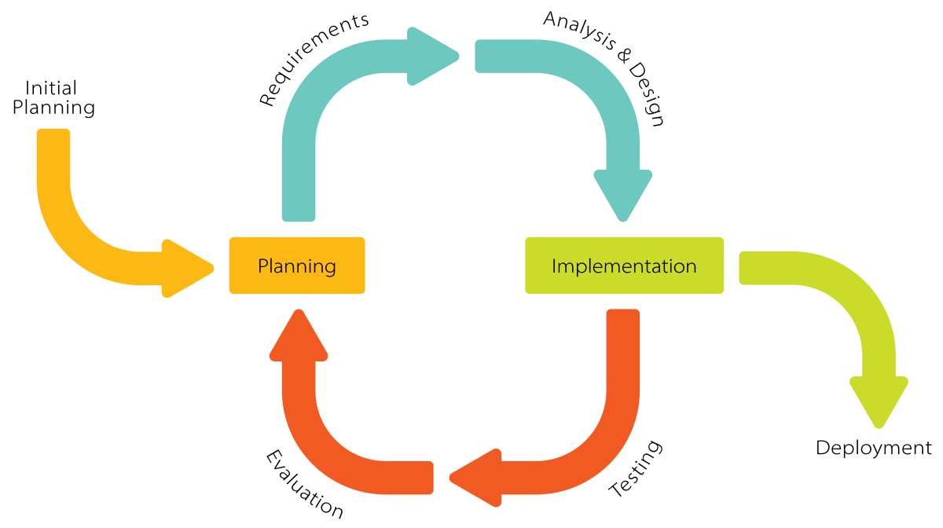
Figure 1: Iterative Process Model

System Overview
Complytics is an AI-assisted platform designed to automate the evaluation of organizational documents against defined compliance frameworks. It supports features like document uploading, metadata tagging, RAG status highlighting, regulation and clause mapping, and interactive responses through a RAG-based assistant. The platform includes modules for compliance evaluation, user and role management, dashboards, and system configuration.
The system is modular in design, with each feature encapsulated within its respective component to ensure ease of development, testing, and maintenance. It allows authorized users to view compliance summaries, manage regulation templates, and update system configurations as needed. The overall design ensures usability, scalability, and adaptability to meet the compliance needs of various organizational structures.

Architectural Design
The architecture we are using is Modular Layered Architecture in which the system is divided into loosely coupled or independent modules or layers. If you see the diagram, our project is split into 3 main layers, namely
The advantages of this approach are as follows:
- This approach ensures loose coupling, meaning that if one module is affected others work properly
- Helps in maintaining good uptime as the modules are decoupled, in case of failure it can be isolated preventing the whole system from collapsing
- Easier to scale as when we want to add new agents or add support for more cloud platforms, we can do that without impacting the whole code base. All we have to do is update knowledge base and the rules are ready.

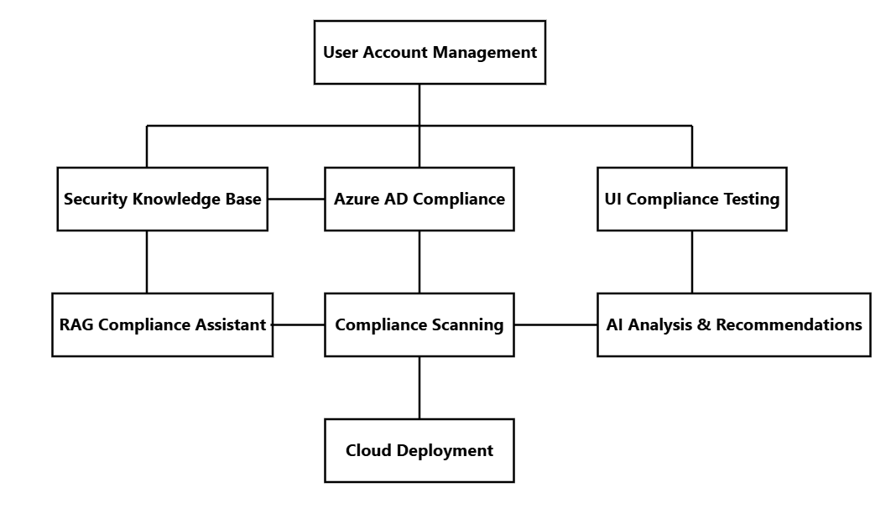
Figure 2: Box and Line Diagram

Figure 3 illustrates the overall system architecture of Complytics, detailing its core components and interactions. It provides a high-level view of how different modules collaborate to enable automated compliance management.

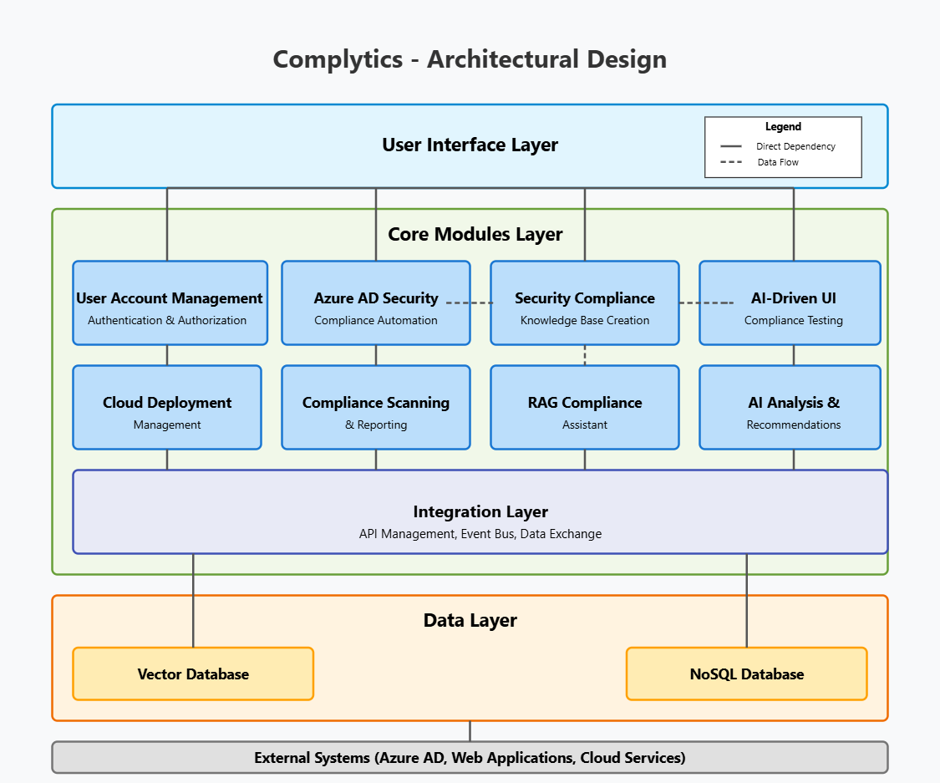
Figure 3: Complytics Architectural Diagram

Design Models

Activity Diagram

Superadmin Login
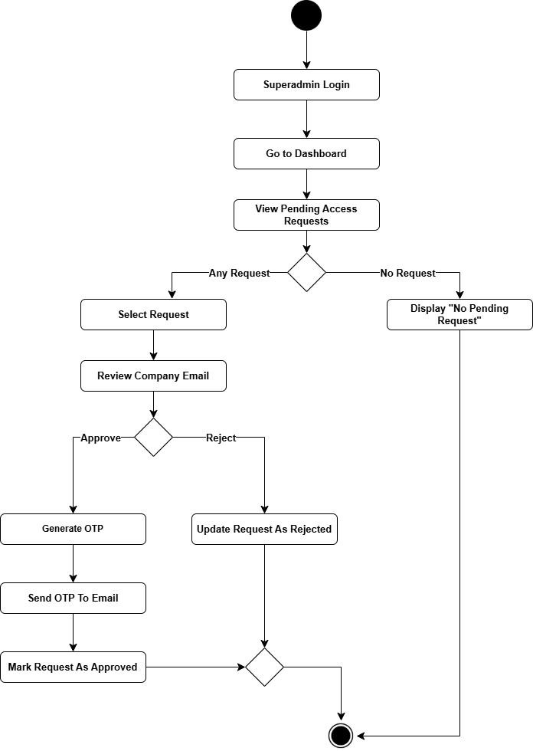

Figure 4: Superadmin Login

Admin Login

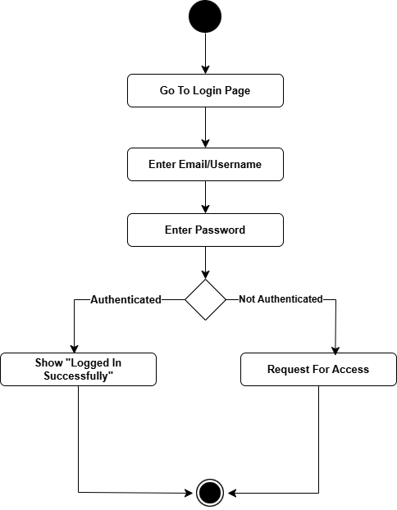
Figure 5: Admin Login

Admin Add Team Member

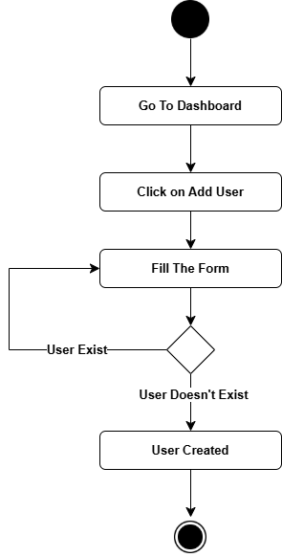
Figure 6: Admin Add Team Member

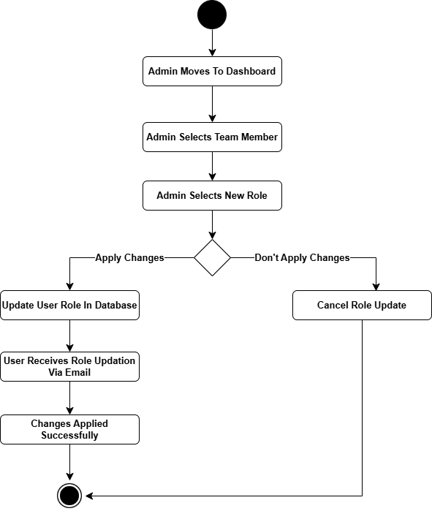
Admin Updates Team Member Role

Figure 8: Admin Updates Team Member Role

Admin Updates Team Member Role

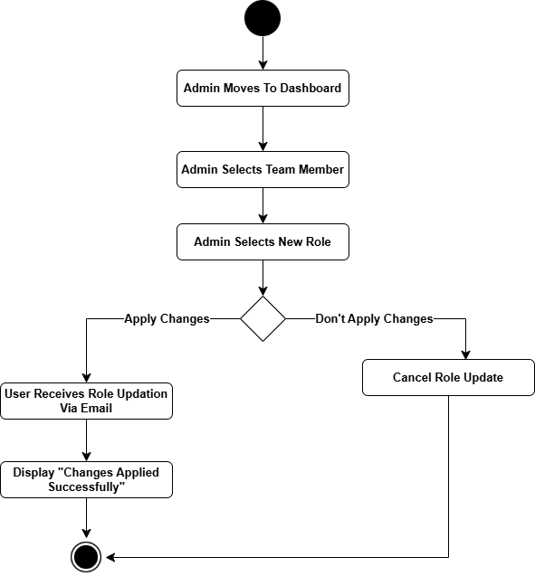
Figure 9: Admin Update Team Members

Compliance Team Performs Compliance Scan

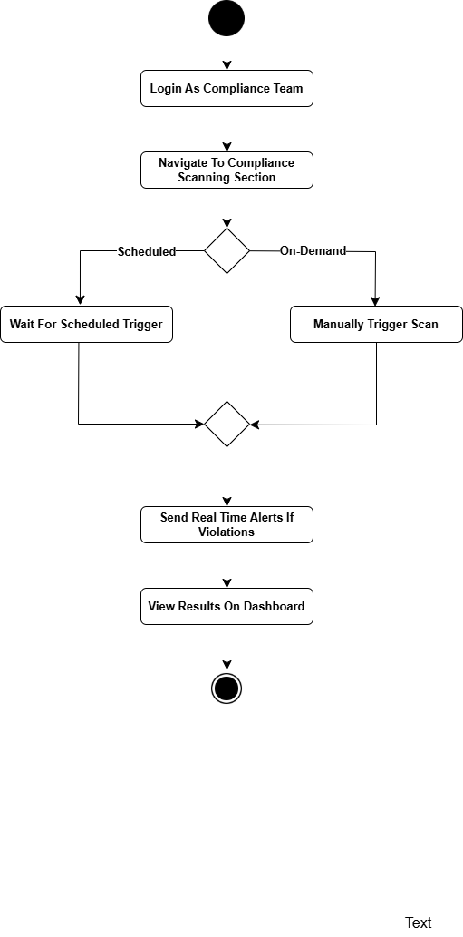
Figure 9: Monitoring and Scheduling Compliance Scans

Generate Framework Specific Compliance Report

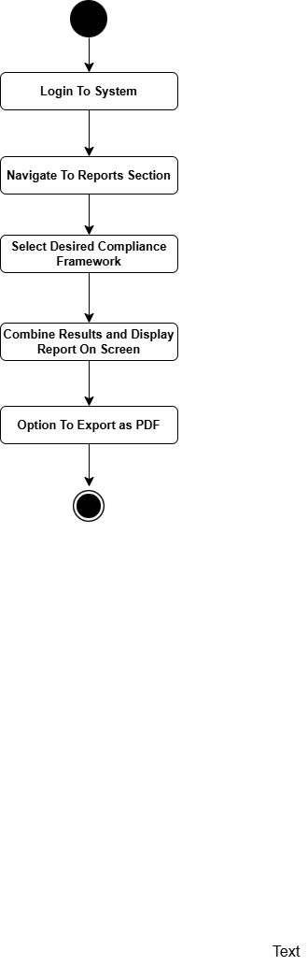
Figure 10: Generating Framework Specific Report

Compliance/IT Team use Compliance Chatbot

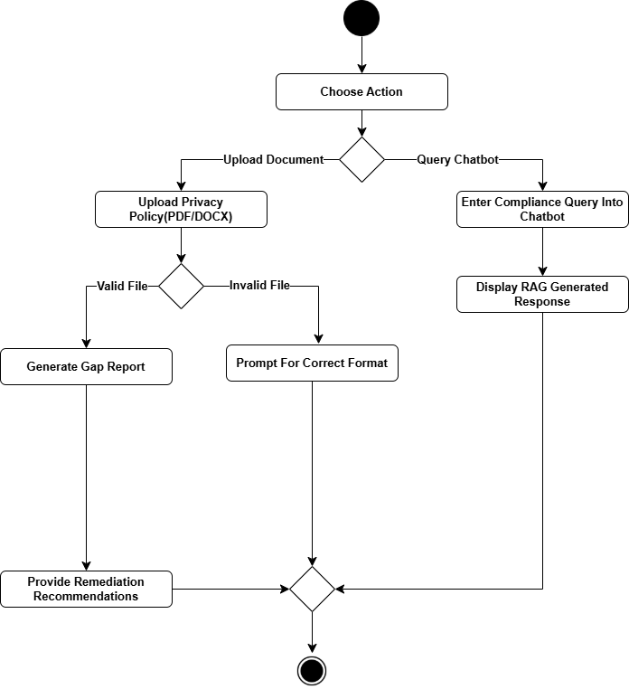
Figure 11: Compliance/IT Team use RAG chatbot

Review AI Generated Compliance Recommendations

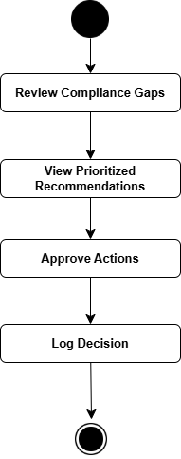
Figure 12: Review & Approve AI Generated Recommendations

Compliance Team performs UI Testing

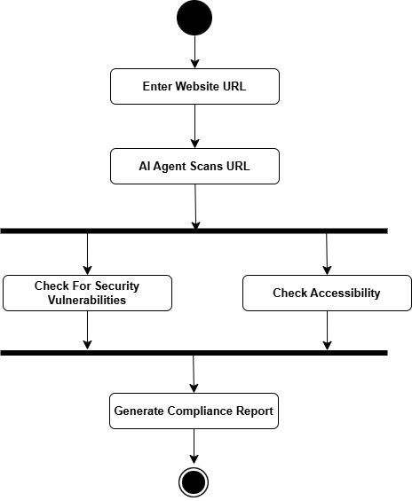
Figure 13: UI Compliance Testing

IT Team Connects to Azure AD

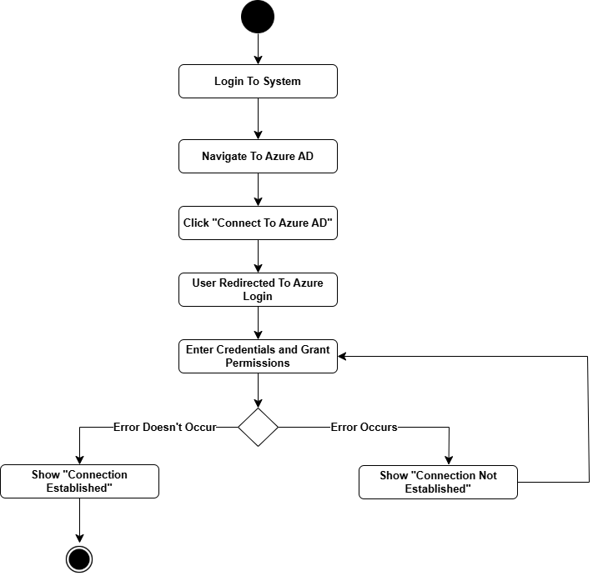
Figure 14: IT Team Connects to Azure AD

Reviewing & Approving Azure AD Configuration Changes
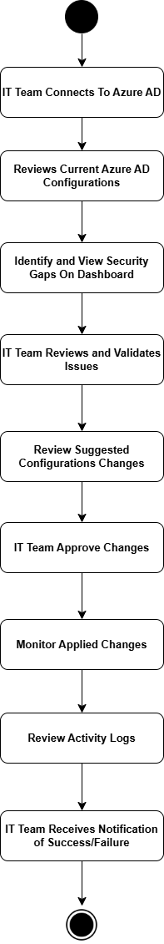
Figure 15: IT Team Reviews and Approves Azure AD changes

IT Team Views Azure AD Change Logs

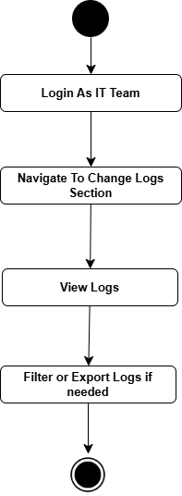
Figure 16: IT Team Views Azure AD Change Logs

Teams View Compliance Dashboard

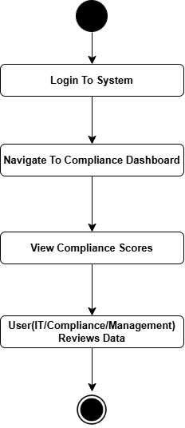
Figure 17: All Teams View Compliance Dashboard

Class Diagram
The class diagram provides a structured overview of the Complytics system’s key components and their relationships, illustrating the platform’s object-oriented design. It highlights core classes such as User (with subclasses SuperAdmin, Admin, and TeamMember), AzureADConnection for cloud integration, ComplianceScan and UITest for automated checks, and RAGModel for AI-driven compliance assistance. Associations like inheritance, management roles, and dependency links (e.g., Dashboard displaying ComplianceReport) clarify interactions between modules, ensuring modularity and scalability. This diagram serves as a blueprint for implementation, aligning with the system’s functional requirements and architectural design.
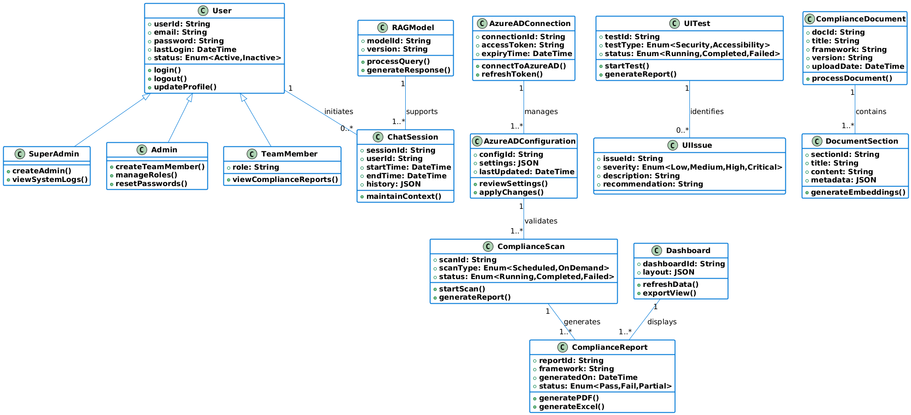

Figure 18: Class Diagram of Complytics

Sequence Diagrams

Login (For All Users)
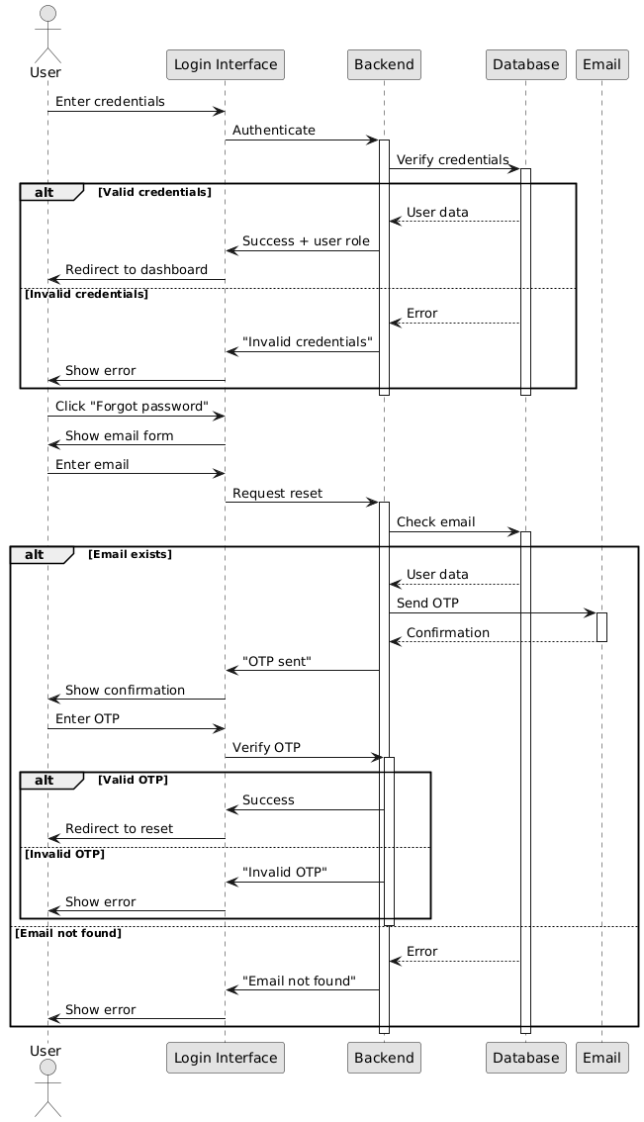

Figure 19: Login For All Users

Organization Admin Onboarding

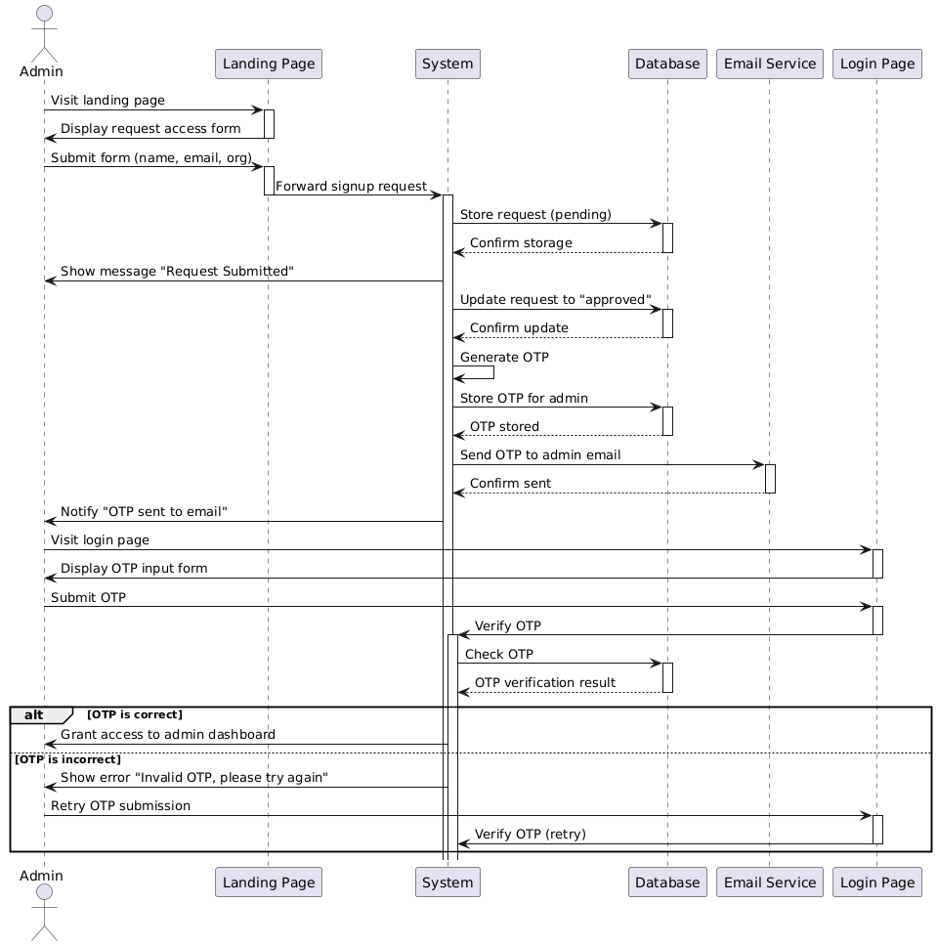
Figure 20: Organization Admin Onboarding

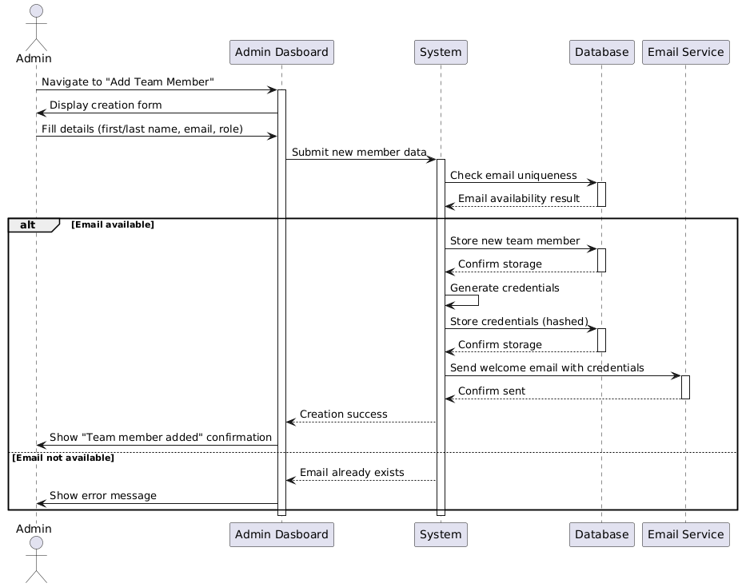
Admin Creates Team Member
Figure 21: Admin Create Team Member

Admin Edits Team Member

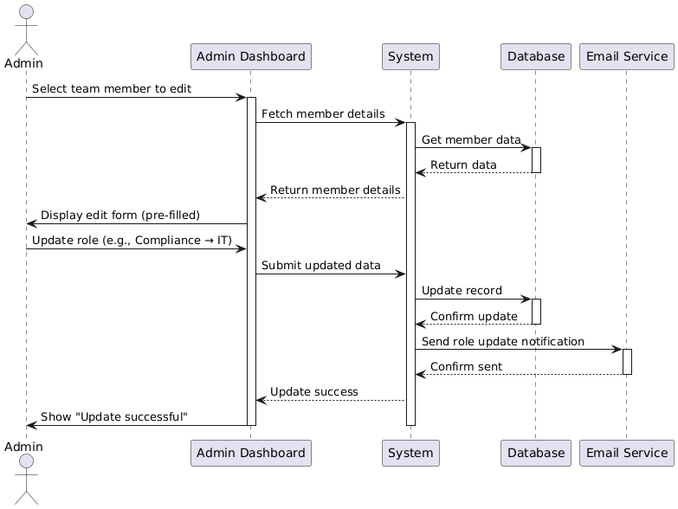
Figure 22: Admin Edit Team Member

Admin Delete Team Member

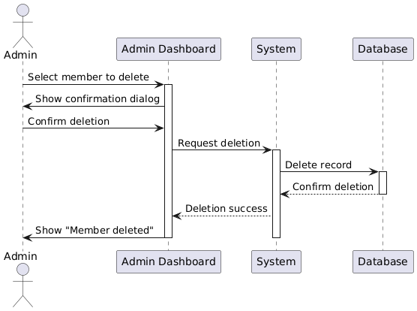

Figure 23: Admin Delete Team Member

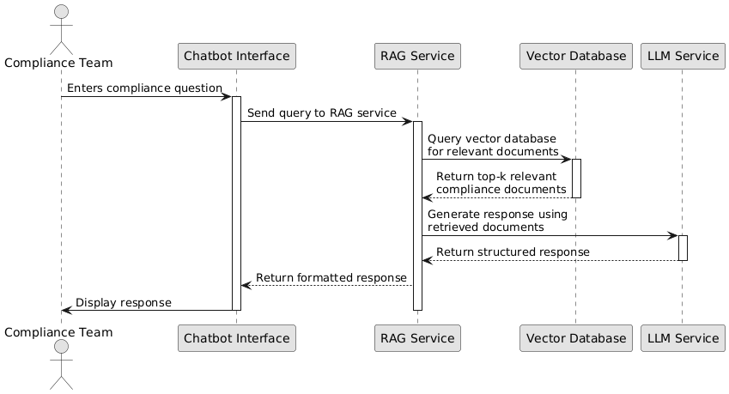
Compliance/IT Team Use RAG Chatbot

Figure 24: Compliance/IT Team Use RAG Chatbot

Management Team View and Generate Report

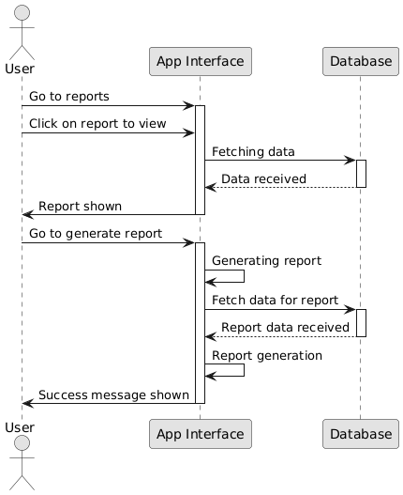

Figure 25: Management Team View and Generate Report

Azure AD Configuration Automation
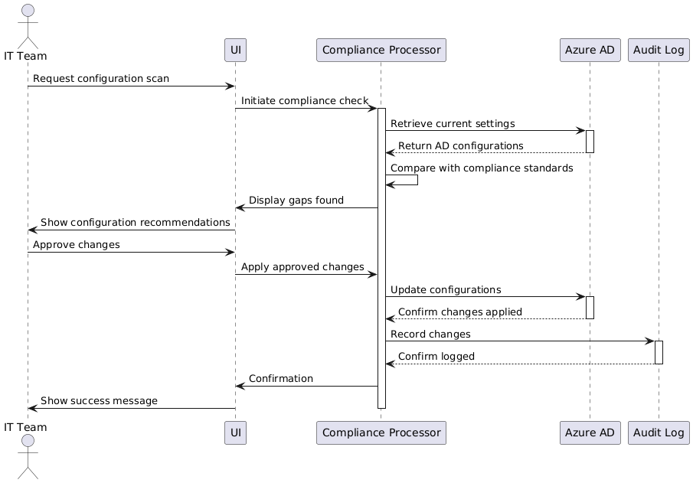

Figure 26: Azure AD Configuration Automation

UI Compliance Testing
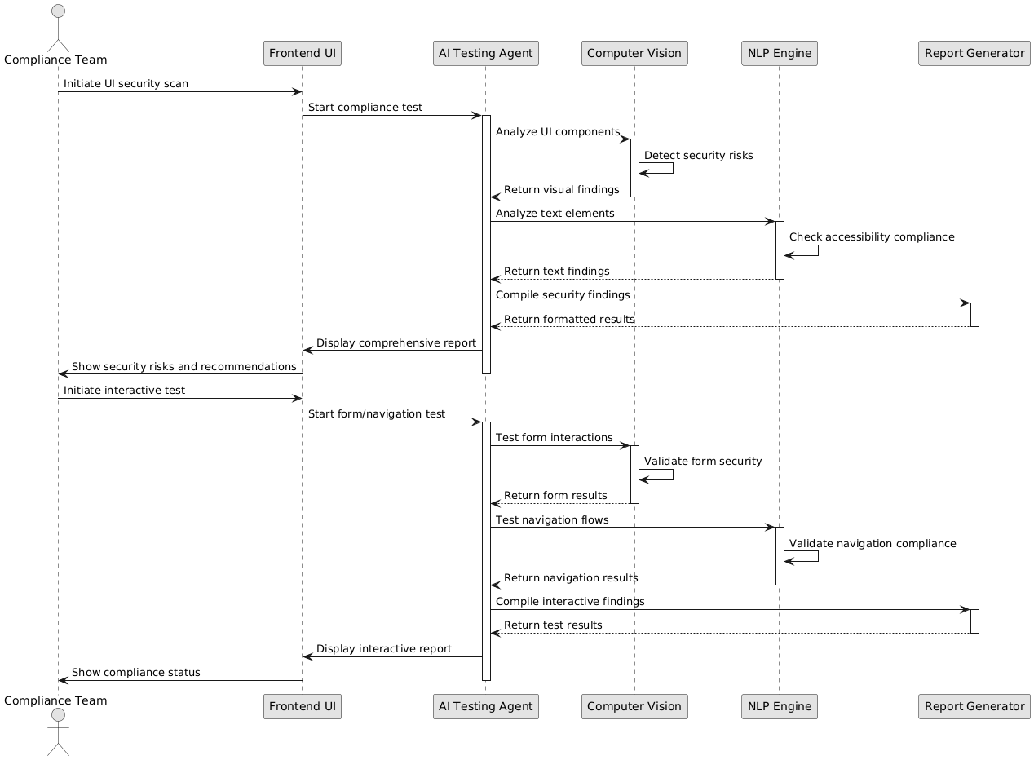

Figure 27: UI Compliance Testing

Data Design for Complytics

Data Dictionary
This section outlines the data schema used within the Complytics platform. It includes a detailed Data Dictionary for each major data entity in the system.
Primary Data Entities
- User
- PendingRegistration
- Organization
- ComplianceDocument
- ChatSession

User
Stores information about all system users, including Superadmins, Admins, and Team Members.
Schema

{
_id: ObjectId,
email: String,
first_name: String,
last_name: String,
password_hash: String,
organization_name: String,
organization_domain: String,
role: { type: String, enum: ['superadmin', 'admin', 'team_member'] },
organization_id: ObjectId,
is_active: { type: Boolean, default: true },
created_at: { type: Date, default: Date.now },
updated_at: { type: Date, default: Date.now },
created_by: String
}

Fields

Field | Type | Description
_id | ObjectId | Unique identifier for the user. Required.
email | String | Unique email address. Required.
first_name | String | First name of the user. Required.
last_name | String | Last name of the user. Required.
password_hash | String | Hashed password. Required.
organization_name | String | Name of the associated organization. Required.
organization_domain | String | Domain of the organization. Required.
role | String | User role: superadmin, admin, or team_member. Required.
organization_id | ObjectId | Reference to the Organization collection. Required.
is_active | Boolean | Status of the account. Defaults to true.
created_at | Date | Timestamp of creation. Auto-generated.
updated_at | Date | Timestamp of last update. Auto-generated.
created_by | String | Creator's identifier (e.g., superadmin ID). Required.

Pending Registration
Stores pending user registrations awaiting approval.

Schema
{
_id: ObjectId,
user_data: {
email: String,
first_name: String,
last_name: String,
password: String,
organization_name: String,
organization_domain: String
},
is_approved: { type: Boolean, default: false },
approved_by: String,
approved_at: Date,
created_at: { type: Date, default: Date.now }
}

Fields
Field | Type | Description
_id | ObjectId | Unique identifier for the request. Required.
user_data.email | String | Email of the pending user. Required.
user_data.first_name | String | First name. Required.
user_data.last_name | String | Last name. Required.
user_data.password | String | Plain password (to be hashed). Required.
user_data.organization_name | String | Organization name. Required.
user_data.organization_domain | String | Domain of the organization. Required.
is_approved | Boolean | Approval status. Defaults to false.
approved_by | String | Approver’s identifier. Null if not approved.
approved_at | Date | Timestamp of approval. Null if not approved.
created_at | Date | Timestamp of registration request. Auto-generated.

Organization
Represents a registered organization in the system.

Schema
{
_id: ObjectId,
name: String,
domain: String,
is_active: { type: Boolean, default: true },
created_at: { type: Date, default: Date.now },
updated_at: { type: Date, default: Date.now },
created_by: String
}

Fields
Field | Type | Description
_id | ObjectId | Unique organization identifier. Required.
name | String | Name of the organization. Required.
domain | String | Domain name. Required.
is_active | Boolean | Organization status. Defaults to true.
created_at | Date | Timestamp of creation. Auto-generated.
updated_at | Date | Timestamp of last update. Auto-generated.
created_by | String | Creator’s identifier (e.g., superadmin ID). Required.

5.1.4 Compliance Document
Holds documents processed by the RAG module for compliance evaluation.

Schema
{
_id: ObjectId,
document_name: String,
framework_type: { type: String, enum: [...] },
file_url: String,
file_type: { type: String, enum: [...] },
processed_text: String,
},
uploaded_by: ObjectId,
uploaded_at: { type: Date, default: Date.now },
last_accessed: { type: Date, default: Date.now }
}

Fields
Field | Type | Description
_id | ObjectId | Unique identifier for the document. Required.
document_name | String | Name of the document. Required.
framework_type | String | Type of compliance framework (e.g., ISO27001). Required.
file_url | String | File storage path or URL. Required.
file_type | String | Format of the file (PDF, DOCX, etc.). Required.
processed_text | String | Extracted and cleaned text from the document. Required.
vector_embedding | Array | Embeddings used for semantic search. Required.
metadata.version | String | Framework version. Required.
metadata.publish_date | Date | Document publication date. Optional.
metadata.sections | Array | Sections including ID, title, and page numbers.
uploaded_by | ObjectId | Uploader's user ID. Required.
uploaded_at | Date | Timestamp of upload. Auto-generated.
last_accessed | Date | Last access timestamp. Auto-updated.

ChatSession
Stores chat logs and references used by the RAG Compliance Assistant.

Schema
{
_id: ObjectId,
user_id: ObjectId,
organization_id: ObjectId,
messages: [{
content: String,
sender: { type: String, enum: ['user', 'assistant'] },
timestamp: { type: Date, default: Date.now }
}],
framework_context: { type: String, enum: [...] },
is_active: { type: Boolean, default: true }
}

Fields
Field | Type | Description
_id | ObjectId | Unique identifier for the chat session. Required.
user_id | ObjectId | Reference to the User. Required.
organization_id | ObjectId | Reference to the Organization. Required.
messages.content | String | Message text. Required.
messages.sender | String | Sender of the message (user or assistant). Required.
messages.timestamp | Date | When the message was sent. Auto-generated.
messages.references | Array | Referenced documents with section ID and confidence score.

Implementation
This section contains the implementation details of the system developed so far. It includes the algorithms, external APIs used by the system, user interface design and deployment details.

Algorithm
Following are the major algorithms used in implementing the functionality of the system developed so far.

Algorithm
Mention the algorithm(s) used in your project to get the work done with regards to major modules. Provide a pseudocode explanation regarding the functioning of the core features. Be sure to use the correct syntax and semantics for algorithm representations.
Algorithm 1 SecurityComplianceMonitoringSystem
Input: Azure AD environment configuration, security policies
Output: Compliance status report and remediation actions
1: Initialize monitoring system
2: While (system is active) do:
3: For each security policy in policies:
4: Check current state against policy requirements
5: If (state ≠ required_state) then
6: Generate violation report
7: If (auto_remediation_enabled) then
8: Execute remediation action
9: End if
10: End if
11: End for
12: Wait for next monitoring interval
13: End while

Algorithm 2 UITestingAutomation
Input: UI components, accessibility standards, security requirements
Output: Test results and compliance report
1: For each UI component:
2: Run accessibility tests:
3: Check color contrast ratios
4: Verify screen reader compatibility
5: Test keyboard navigation
6: Run security tests:
7: Check input validation
8: Test XSS vulnerabilities
9: Verify CSRF protection
10: Generate test report
11: If (test_failed) then
12: Log failure details
13: Suggest remediation steps
14: End if
15: End for

Algorithm 3 ComplianceAssistantChatbot
Input: User query, compliance knowledge base
Output: Relevant compliance information and guidance
1: Process user query
2: Extract key terms and intent
3: Search knowledge base for relevant information
4: If (exact_match_found) then
5: Return direct answer
6: Else
7: Use semantic search to find related content
8: Rank results by relevance
9: Generate contextual response
10: End if
11: Update learning model with interaction data

Algorithm 4 KnowledgeBaseManagement
Input: Compliance documentation, policies, procedures
Output: Organized and searchable knowledge repository
1: For each document:
2: Extract metadata:
3: Document type
4: Version
5: Last updated
6: Access permissions
7: Index content for search
8: Apply version control
9: Set access controls
10: End for
11: While (system is active) do:
12: Monitor for updates
13: If (update_detected) then
14: Update version
15: Notify relevant users
16: End if
17: End while

Algorithm 5 AutomatedComplianceReporting
Input: Compliance data, reporting requirements
Output: Formatted compliance reports
1: Collect compliance data from all sources
2: For each reporting requirement:
3: Extract relevant metrics
4: Calculate compliance scores
5: Generate visualizations
6: Format data according to requirements
7: End for
8: Compile final report
9: If (report_needs_approval) then
10: Send for review
11: If (approved) then
12: Distribute report
13: Else
14: Revise based on feedback
15: End if
16: End if

Algorithm 6 UserAuthenticationAndAuthorization
Input: User credentials (email, password)
Output: Authentication token and user data
1: Function authenticate_user(email, password):
2: If (email == superadmin_email) then
3: If (password == superadmin_password) then
4: Return superadmin user object
5: End if
6: End if
7: user ← Find user in database by email
8: If (user not found) then
9: Return null
10: End if
11: If (verify_password(password, user.password_hash)) then
12: Return user object
13: End if
14: Return null

Algorithm 7 UserRegistrationProcess
Input: User registration data (email, name, organization details)
Output: Registration status
1: Function register_organization_admin(user_data):
2: Check if email exists in users collection
3: If (email exists) then
4: Return error "Email already registered"
5: End if
6: Check if email exists in pending registrations
7: If (email exists) then
8: Return error "Email already pending approval"
9: End if
10: Create pending registration document:
11: - User data
12: - is_approved = false
13: - approved_by = null
14: - approved_at = null
15: - created_at = current_timestamp
16: Store in pending_registrations collection
17: Return success message

Algorithm 8 RegistrationApprovalProcess
Input: Registration ID, Approver user
Output: Approved user account
1: Function approve_registration(registration_id, current_user):
2: Find and delete pending registration
3: If (registration not found) then
4: Return error "Registration not found"
5: End if
6: Check if user already exists
7: If (user exists) then
8: Return error "User already exists"
9: End if
10: Create organization:
11: - Name
12: - Domain
13: - Created by
14: - Timestamps
15: Generate temporary password
16: Create admin user:
17: - User data
18: - Hashed password
19: - Role = "admin"
20: - Organization ID
21: - Timestamps
22: Send credentials email
23: Return created user

Algorithm 9 RoleBasedAccessControl
Input: User token, Requested resource
Output: Access granted/denied
1: Function check_access(user_token, resource):
2: Decode JWT token
3: Extract user role and email
4: If (email == superadmin_email) then
5: Return superadmin user object
6: End if
7: Find user in database
8: If (user not found) then
9: Return error "User not found"
10: End if
11: Switch (user.role):
12: Case "superadmin":
13: Grant full access
14: Case "admin":
15: Grant organization-level access
16: Case "it_team":
17: Grant IT-specific access
18: Case "compliance_team":
19: Grant compliance-specific access
20: Case "management_team":
21: Grant management-specific access
22: Default:
23: Deny access
24: End switch

Algorithm 10 SessionManagement
Input: User token
Output: Session status
1: Function manage_session(token):
2: If (token not in localStorage) then
3: Redirect to login
4: End if
5: Try:
6: Verify token with backend
7: If (token valid) then
8: Update session data
9: Return active session
10: Else
11: Clear local storage
12: Redirect to login
13: End if
14: Catch error:
15: Clear local storage
16: Redirect to login
17: End try

